|  |  |  |  |
| --- | --- | --- | --- |
| \\lyng-dc1\StaffShared\Learning Bugs Animals ALL subjects\characters bugs animals\Cyril the Snail - History.jpeg**Lyng Primary School Knowledge Organiser** | | | |
| **History Topic:** | **The Victorians - How did life change in the Victorian era?** | Year 6  *Civilisation, Communication and Inventions* | Spring Term |

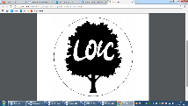

**Trip/ Visit –  
 Black Country Living Museum**

Victorian Day, we are the child labourers

**Background information**

The period of time between 1837 to 1901 when Queen Victoria reigned over Britain. During her 63 year reign, there was a huge contrast between how the rich and poor Victorians lived. Queen Victoria led the expansion of the British empire and saw major changes to all aspects of Britain due to exciting discoveries and inventions

|  |  |
| --- | --- |
| **What Step On and Goldilocks words will I use?** | |
| **Spelling** | **Definition** |
| Blacksmith | A person who makes and repairs things in iron by hand. |
| Census | An official survey of the population that is carried out every ten years. |
| Chain maker | A low-paid person who made chains out of metal. |
| Coal hewer | A low-paid person who was a coal-face worker who dug for coal, loosening the coal with a pick. |
| Condition | A term used to refer to whether someone was married or not. |
| Enumerator | A person employed to collect census forms and enter them into the enumeration book. |
| Farrier | A smith who shoes horses. |
| Flax | Fibres are taken from beneath the stem of the plant and turned into flax yarn. |
| Foundry | A workshop or factory for casting metal. |
| Head of household | The person who makes the money to support the household and makes important decisions. |
| Iron founder | One who founds or makes castings in iron. |
| Schedule | The census form was taken around to households until 1901. The form was filled in and collected by the enumerator. |
| Scholar | A term used on the census to indicate someone attending school or a child. |
| Shilling | Part of the former British currency, a shilling was worth twelve pence. |
| Suffragette | A woman who campaigned for the right to vote. |
| Textile Mill | A mill that turns fibre into yarn and then yarn into fabric. |
| Yarn | Interlocking fibres created by spinning, which are used in textiles, knitting and sewing. |



**Enquiry questions that we shall investigate during the topic:**

**What does the census tell us about the people living in our local area?**

**How can a census record show how lives changed?**

**How differently were people treated in the past?**

**What was the impact of the industrial revolution?**

**How were occupations different in the past?**

|  |  |
| --- | --- |
| **Queen Victoria (1819-1901)**  Victoria was the Queen of the United Kingdom of Great Britain and Ireland from 20th June 1837 until 22nd January 1901. On 1st May 1876 she was granted the additional title of ‘Empress of India.’ Her reign of 63 years and 7 months was the longest of any British monarch aside from Queen Elizabeth II, and was known as the Victorian era. Although much of the ruling power at the time was already handed to the government, Victoria still held significant sway in the rule of the country and empire. She became a national icon aligned with the strict standards of personal morality that are associated with the time. She married her cousin, Prince Albert of Saxe-Coburg and Gotha in 1840 – their nine children married into noble families all across Europe, earning her the nickname ‘the grandmother of Europe.’ When Albert died in 1861, Victoria sank into deep mourning. She died in 1901 at the age of 81. | |
| **Charles Dickens (1812-1870)**  Charles Dickens was a writer, who is widely regarded as the greatest novelist of the Victorian era. His works, including *Oliver Twist*, *Great Expectations* and *A Christmas Carol* were extremely popular during his lifetime, and have gained even further recognition since. His novels often dealt with the harsh social conditions experienced by the poor at the time, critiquing the attitudes of those with power and wealth. | **Charles Darwin (1809-1882)**  Charles Darwin was a naturalist and biologist who is best known for his theory of evolution. Darwin established that all species share common ancestors, and that natural selection has shaped the diversity of life on earth. Whilst his theories were initially rejected by many in scientific, religious, and public circles, they are now broadly considered as scientific fact. Darwin has been described as one of the most influential figures in history. |



**Victorian Timeline**

**Our Storytelling Approach to enhance engagement**

|  |  |  |
| --- | --- | --- |
| **People:**  A young orphan child | **Place:**  Workhouse - London | **Problem:**  Needs to flee the workhouse |

**Key Historical Facts**

**Focus Texts**

|  |  |  |  |
| --- | --- | --- | --- |
| **Important Events and Life in Victorian Times** | | | |
| The Industrial Revolution |  | Around 1760-1850 In the Industrial Revolution, the manufacturing of goods moved from small shops to large factories. This meant that more people moved into the cities. It was a time of new technologies and a new, more modern way of life. | Key Fact:  Queen Victoria took to the throne at the very end of the revolution. |
| The Irish Potato Famine | Around 1945-1949 In the early 19th Century, potatoes were the main source of food and income in Ireland. A fungus: ‘potato blight’ made the potatoes rot, to catastrophic effect: about 800,000 died, and 1 million emigrated to the UK and the US. | | Key Fact:  Many blamed the British government’s inaction for the depth of the tragedy. |
| The Public Health Act 1848 | Initiated in 1848 The Public Health Act was drafted in response to requests to improve public health conditions in poor areas, where sewage openly flowed through the streets. It is seen as the first step on the road towards improved public health. | | Key Fact:  The act was unpopular with many, seen as a government intrusion. |
| Origin of the Species Published | November 24th 1859 Darwin’s masterpiece resulted from over 20 years of research. It caused an immediate stir, as it directly contradicted the bible’s creation story. It was initially rejected by many. | | Key Fact:  The paper was translated into 8 different languages in Dariwn’s lifetime. |
| Prince Albert’s Death |  | 14th December, 1861  Prince Albert, Victoria’s husband died from typhoid aged only 42. Victoria withdrew from public life for years. The Queen based her later decisions on what he would have done. | Key Fact:  Throughout Victoria’s reclusive period, a republican movement grew. |
| Class |  | The upper classes was made up of very few people  Despite the revolution, there were still distinct social classes: the upper class, middle class, and working class. Life was terrible for the poorest: Awful working conditions and little food. | Key Fact:  The upper class lived prosperous lives, with servants and cooks. |
| Life for Children |  | Children were often exploited, paid very little for long hours. Until the late 19th Century, education was a reserve of the rich. As many families were so poor, lots of children instead had to work. They worked long hours for little money. | Key Fact:  Only in 1880 did primary schooling become compulsory. |
| Health | Poor public hygiene played a large part in people’s poor health. Medicine was nowhere near as advanced as today, Many diseases were rife, and childbirth and poverty were very real dangers to people living in the era, especially the poor. | | Key Fact:  On average, middle class people lived to 45. Working class were lucky to live half that time. |
| Workhouses | Image result for workhouse | People slept in dormitories, where disease was easily spread. Workhouses were places where a person went if they could not afford to financially support themselves and their families – they quickly became extremely crowded and unpleasant. | Key Fact:  Many orphans ended up growing up in workhouses. |
| Food |  | Workhouses only offered basic rations. As with all aspects of life, there were vast differences between the diets of the rich and poor. The poor survived on little more than potato scraps and rotten vegetables. | Key Fact:  The rich dined on fine foods, using expensive cutlery, with servants. |
| Clothes |  | Poor Victorians had to buy their clothes 2nd hand, For the rich, expensive clothes were a must. Clothes were almost always made to measure. Aristocratic women wore elaborate dresses, blouses and bonnet hats, whilst men wore high-waisted trousers, cravat tops and top hats.  . | Key Fact:  Over the many years of Victoria’s reign, fashion trends changed a great deal! |

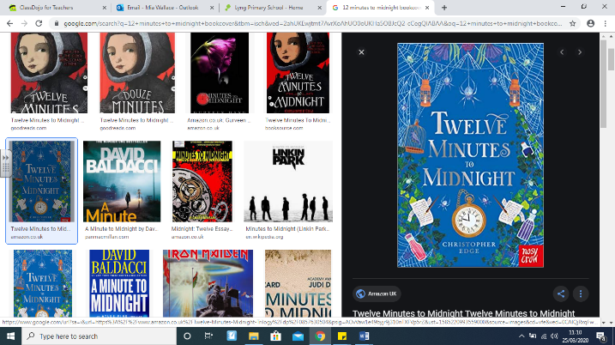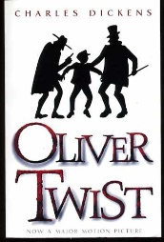

We will focus on ‘Street Child’ by Berlie Doherty as well as reading extracts from ‘Oliver Twist’ a classic by Charles Dickens (the Victorian novelist)

**Agreed Outcome**

A Victorian Narrative inspired by Doherty, Edge and Dickens depicting the life of poor children.

|  |  |  |  |
| --- | --- | --- | --- |
| \\lyng-dc1\StaffShared\Learning Bugs Animals ALL subjects\characters bugs animals\Cyril the Snail - History.jpeg**Lyng Primary School Knowledge Quiz** | | | |
| **History Topic:** | **The Victorians** | Year 6  *Civilisation, Communication and Inventions* | Spring Term |

|  |  |  |
| --- | --- | --- |
| 6. Most Victorian children | **S** | **E** |
| Worked |  |  |
| Went to school |  |  |
| Enjoyed their childhood |  |  |

|  |  |  |
| --- | --- | --- |
| 7. Why did lots of people die in the workhouses? | **S** | **E** |
| They were beaten to death |  |  |
| Disease spread quickly |  |  |
| It was too cold |  |  |

|  |  |
| --- | --- |
| 8. What was the danger of working in a textile mill? | |
| **S** |  |
| **E** |  |

|  |  |
| --- | --- |
| 9. List three occupations for local people of the Black Country. | |
| **S** | **E** |
|  |  |
|  |  |
|  |  |

|  |  |
| --- | --- |
| 10. Explain one major change during the Victorian era. | |
| **S** |  |
| **E** |  |

|  |  |  |
| --- | --- | --- |
| 1. The Upper Class is made up of | **S** | **E** |
| Poor People |  |  |
| Rich People |  |  |
| The Royal family |  |  |

**Our Victorian**

**Quick Quiz**

|  |  |  |
| --- | --- | --- |
| 1. What is a census | **S** | **E** |
| A population survey |  |  |
| A period of 100 years |  |  |
| Today’s equivalent of £100 |  |  |

|  |  |  |
| --- | --- | --- |
| 1. How many pence were in a shilling? | **S** | **E** |
| 10 |  |  |
| 11 |  |  |
| 12 |  |  |

|  |  |  |
| --- | --- | --- |
| 1. A coal hewer was a well-paid, prestigious job. | **S** | **E** |
| True |  |  |
| False |  |  |

|  |  |
| --- | --- |
| 1. Where did most orphans grow up? | |
| **S** |  |
| **E** |  |